James Hopkins

# Colour Change Game - Name Unknown

# General Overview

### Theme/Setting/Genre

2D Platformer and Combat game.

The setting of the game will be a battle arena that decides the answer of the aforementioned question.

### Targeted Platforms

* Steam

### Budget

$100 for distribution on Steam

### Time Scale

This is a side project so I will add to it when I can. Hoping to have a Minimal Viable Product by December.

### Team

James Hopkins. Will look for 2D artists.

### Brief description of project

The game will have multiple scenarios with two opposing factions. For example, a story could be red people are fighting blue people for some land. User chooses which colour to side with and plays as that colour. Or a guy is asking a girl out and the user will pick Yes or No to fight for.

Option Addition: Add a custom game mode that allows users to input their own fights, and let them choose if it is a colour fight, or a Yes/No fight.

# Assets Required

* Player Character

The characters of the battle arena will look the same, but if the opposing team will have a different colour to them. For an example, here's an image of Mushroom Wars 2:

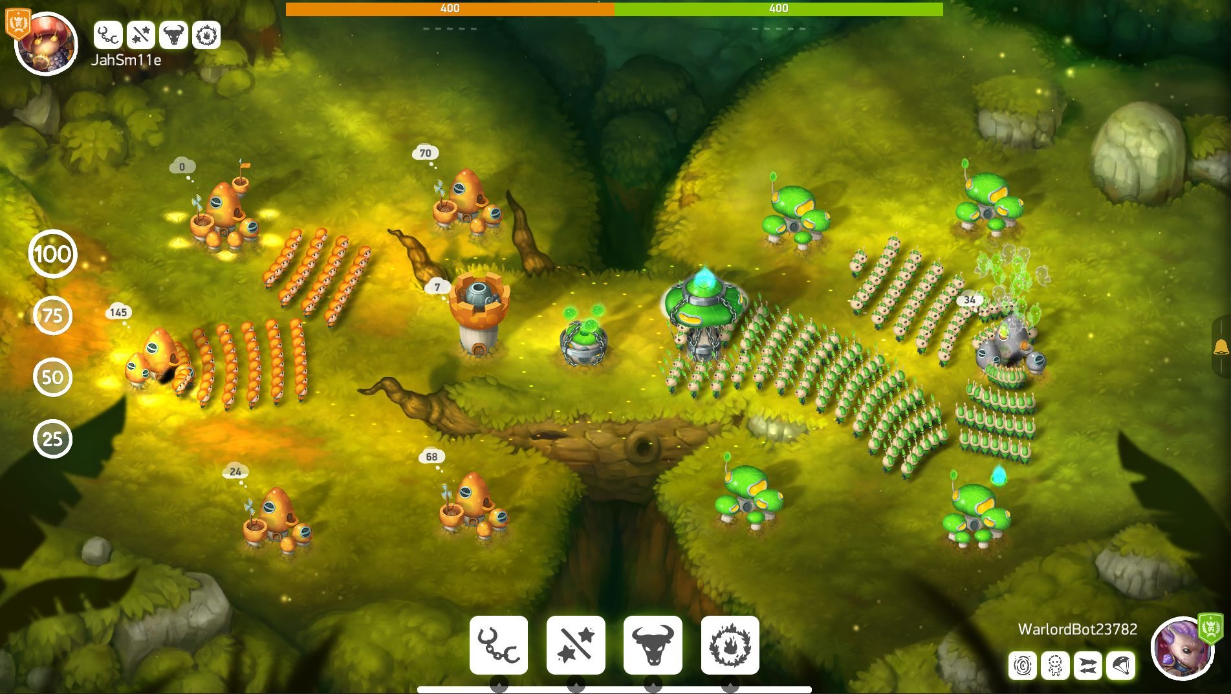

* Level Ledges,
* Level props (trees, weird brain stuff)
* Story Boards (the board that shows what the story is that lets people decide who to fight for)
* Buttons